TCODE SE24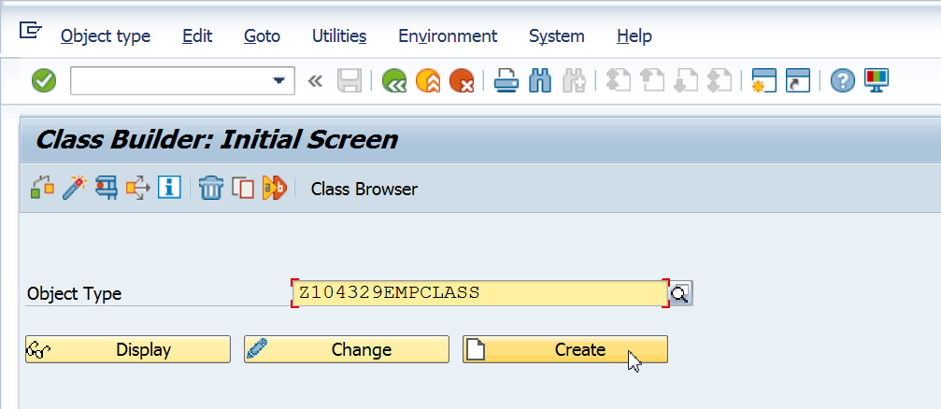

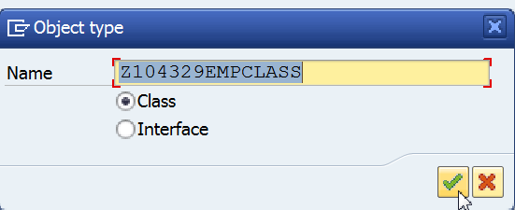

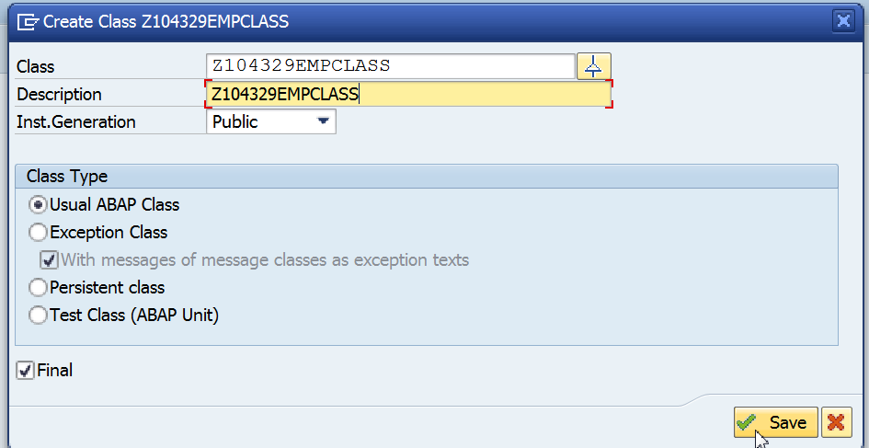

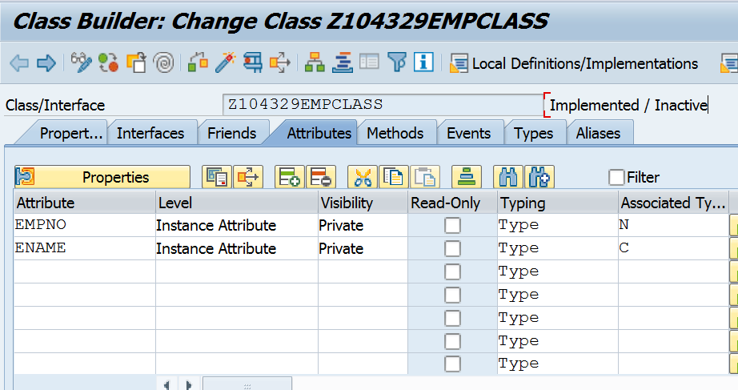

Click on

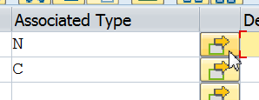

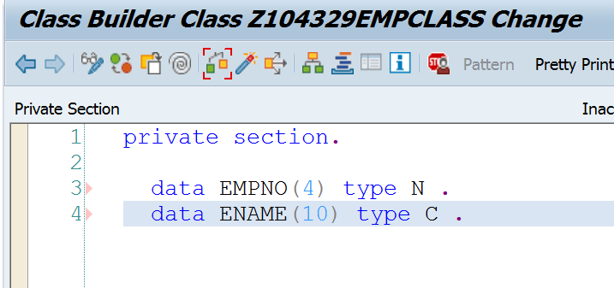

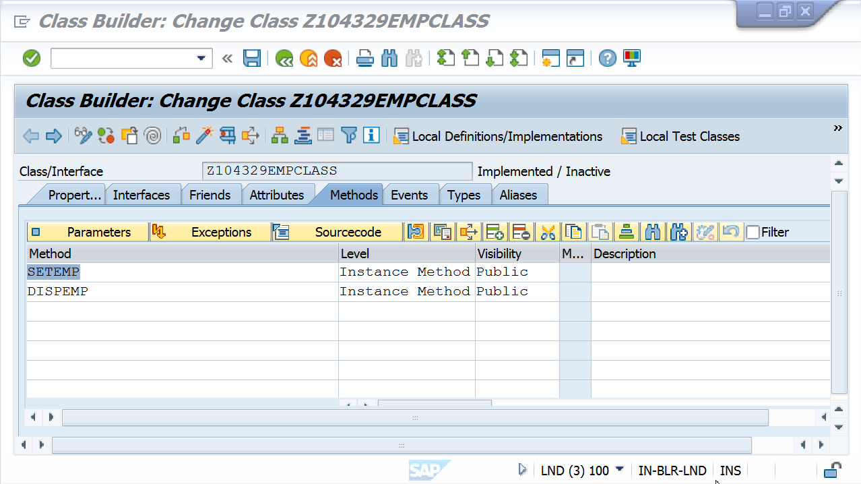

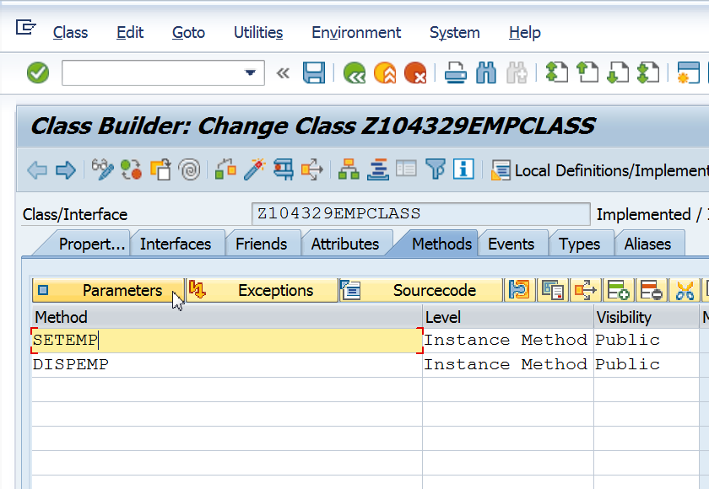

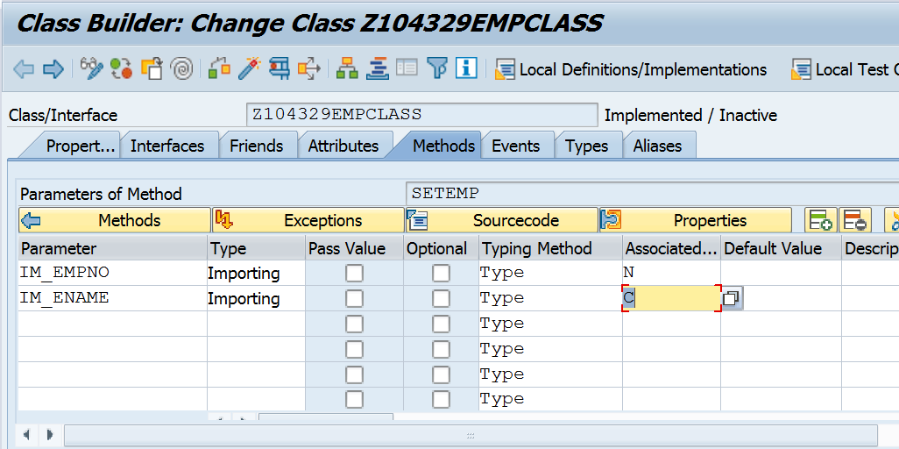

SAVE AND CLICK ON CODE BUTTON  AND CAN WRITE YOUR CODE

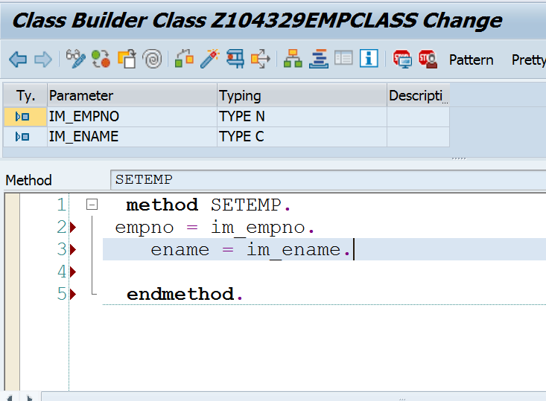

WAYS TO CALL FUNCTIONS

These are the possibilities of an inline method call.

If you are calling so called functional method which has only IMPORTING parameters and optionally one RETURN parameter you can call it like this.

CLASS lcl_test DEFINITION.

PUBLIC SECTION.

CLASS-METHODS:

func_meth

IMPORTING

i_param TYPE i

RETURNING

VALUE(r_res) TYPE char1.

ENDCLASS.

l_res = lcl_test=>func_meth( 1 ).

* you could also call it like this

l_res = lcl_test=>func_meth( i_param = 1 ).

* also this variant is possible

l_res = lcl_test=>func_meth( EXPORTING i_param = 1 ).

* the traditional CALL METHOD syntax would be like this

CALL METHOD lcl_test=>func_meth

EXPORTING

i_param = 1

RECEIVING

r_res = l_res.

If there is more than one IMPORTING parameter you have to specify names of the parameters.

CLASS lcl_test DEFINITION.

PUBLIC SECTION.

CLASS-METHODS:

func_meth

IMPORTING

i_param1 TYPE i

i_param2 TYPE i

RETURNING

VALUE(r_res) TYPE char1.

ENDCLASS.

l_res = lcl_test=>func_meth(

i_param1 = 1

i_param2 = 2

).

If there are EXPORTING or CHANGING parameters in the method then an inline call is still possible but the parameter categories have to be explicitly specified.

CLASS lcl_test DEFINITION.

PUBLIC SECTION.

CLASS-METHODS:

func_meth

IMPORTING

i_param TYPE i

EXPORTING

e_param TYPE c

CHANGING

c_param TYPE n.

ENDCLASS.

lcl_test=>func_meth(

EXPORTING

i_param = 1

IMPORTING

e_param = l_param

CHANGING

c_param = l_paramc

).